MUJTABA SHAHID FAIZI

BSCS-5A

131818

WEB LAB 9

TASK 2:

<!doctype html>

<html>

<head>

<meta charset="utf-8">

<style type="text/css">

label{font-size: 20px;}

</style>

<title>form Validation</title>

<link rel="stylesheet" href="https://jqueryvalidation.org/files/demo/site-demos.css">

</head>

<body>

<div align="center">

<br>

<form>

<fieldset>

<legend>Sig-in Form</legend>

<form id="myform">

<label id="myemail"> Email</label>

<input id="myemail" name="myemail" type="email" />

<br/>

<label for="password">Password</label>

<input id="password" name="password" type="password" />

<br/>

<label for="password_again">Confirm Password</label>

<input class="left" id="password_again" name="password_again" / type="password" required>

<br>

</fieldset>

</form>

</div>

<script src="https://code.jquery.com/jquery-1.11.1.min.js"></script>

<script src="https://cdn.jsdelivr.net/jquery.validation/1.16.0/jquery.validate.min.js"></script>

<script>

// just for the demos, avoids form submit

jQuery.validator.setDefaults({

debug: true,

success: "valid"

});

$( "#myform" ).validate({

rules: {

password: "required",

password_again: {

equalTo: "#password"

}, myemail: "required",

myemail2: {

equalTo: "#myemail"

}

}

}

);

</script>

</body>

</html>

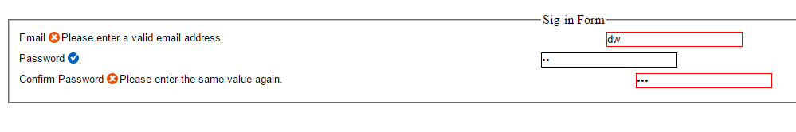

TASK 3:

<!DOCTYPE html>

<html>

<head>

<title></title>

<link href="https://fonts.googleapis.com/css?family=Raleway:400,300,600,800,900" rel="stylesheet" type="text/css">

<style type="text/css">

#container {

left:500px;

top:150px;

width: 400px;

height: 400px;

position: relative;

}

</style>

</head>

<body>

<div id="container"></div>

<script src="https://rawgit.com/kimmobrunfeldt/progressbar.js/1.0.0/dist/progressbar.js"></script>

<script type="text/javascript">

var bar = new ProgressBar.Circle(container, {

color: '#11111',

strokeWidth:65,

trailWidth:1,

easing: 'easeInOut',

duration: 1400,

text: {

autoStyleContainer: false

},

from: { color: '#111111', width: 4 },

to: { color: '#333', width: 1 },

step: function(state, circle) {

circle.path.setAttribute('stroke', state.color);

circle.path.setAttribute('stroke-width', state.width);

var value = Math.round(circle.value() * 100);

if (value === 0) {

circle.setText('');

} else {

circle.setText(value);

}

}

});

bar.text.style.fontSize = '50px';

bar.animate(1.0);

</script>

</body>

</html>

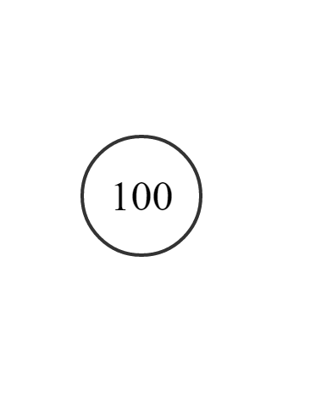

Task 1:

<!DOCTYPE html>

<html lang="en">

<head>

<title>Bootstrap Example</title>

<meta charset="utf-8">

<meta name="viewport" content="width=device-width, initial-scale=1">

<link rel="stylesheet" href="https://maxcdn.bootstrapcdn.com/bootstrap/3.3.7/css/bootstrap.min.css">

<script src="https://ajax.googleapis.com/ajax/libs/jquery/3.2.0/jquery.min.js"></script>

<script src="https://maxcdn.bootstrapcdn.com/bootstrap/3.3.7/js/bootstrap.min.js"></script>

<style>

.carousel-inner > .item > img,

.carousel-inner > .item > a > img {

width: 70%;

margin: auto;

}

</style>

</head>

<body>

<div class="container">

<br>

<div id="myCarousel" class="carousel slide" data-ride="carousel">

<!-- Indicators -->

<ol class="carousel-indicators">

<li data-target="#myCarousel" data-slide-to="0" class="active"></li>

<li data-target="#myCarousel" data-slide-to="1"></li>

<li data-target="#myCarousel" data-slide-to="2"></li>

<li data-target="#myCarousel" data-slide-to="3"></li>

</ol>

<!-- Wrapper for slides -->

<div class="carousel-inner" role="listbox">

<div class="item active">

<img src="1.jpg" alt="Chania" width="460" height="345">

</div>

<div class="item">

<img src="2.jpg" alt="Chania" width="460" height="345">

</div>

<div class="item">

<img src="3.jpg" alt="Flower" width="460" height="345">

</div>

<div class="item">

<img src="4.jpg" alt="Flower" width="460" height="345">

</div>

</div>

<!-- Left and right controls -->

<a class="left carousel-control" href="#myCarousel" role="button" data-slide="prev">

<span class="glyphicon glyphicon-chevron-left" aria-hidden="true"></span>

<span class="sr-only">Previous</span>

</a>

<a class="right carousel-control" href="#myCarousel" role="button" data-slide="next">

<span class="glyphicon glyphicon-chevron-right" aria-hidden="true"></span>

<span class="sr-only">Next</span>

</a>

</div>

</div>

</body>

</html>